What would happen if you didn’t sleep?
By: Claudia Aguirre
https://tinyurl.com/nosleep141

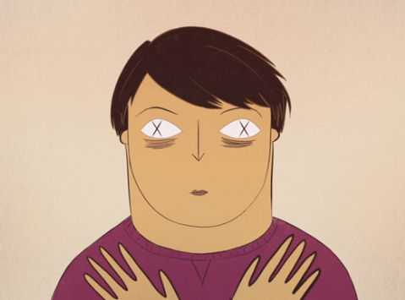
- By the end of Randy Gardner’s experiment, he experienced:
  - Hallucinations
  - Concentration problems
  - Short-term memory problems
  - Paranoia
  - All of the above
- Losing sleep has been linked to
  - Increased inflammation
  - High blood pressure
  - Obesity
  - All of the above
  - None of the above
- How much sleep do adolescents need
  - 5-6 hours
  - 9-10 hours
  - 7-8 hours
  - 12-13 hours
  - 2-3 hours
- This non-REM sleep is when __________ is repaired and our bodies replenish themselves.
- Studies show that approximately _______ percent of adolescents are sleep deprived.
  - 95
  - 66
  - 75
  - 80
  - 30
- Which substance mentioned in the video builds up and causes ‘sleep pressure’?
  - Adenosine
  - Glutamine
  - Histamine
  - Glycine
  - None of the above
- Scientists found something called the glymphatic system. A clean-up mechanism that removes this _____________________ and is much more active when we’re asleep. It works by using cerebrospinal fluid to flush away _____________ by-products that accumulate between cells.
- What are some of the cognitive effects of sleeplessness? (2 points)

